005 TypeScript - var let const

TypeScript Kata List – Blog Page

TypeScript Kata List – Github Page

# Duration

10 minutes

# Brief

Working with var, let, and const and their scopes.

### For More Information

BING/GOOGLE: “TypeScript var let const”

# Instructions

Get tutorial folder or the entire katas-typescript repo.

Open the [before/*.sln] file and execute the kata.

Feel free to execute this kata multiple times because repetition creates motor memory.

# Github

* Before (start kata with this)
  + <https://github.com/robertdunaway/katas-typescript/tree/master/005%20TypeScript%20-%20var%20let%20const/before>
* After
  + <https://github.com/robertdunaway/katas-typescript/tree/master/005%20TypeScript%20-%20var%20let%20const/after>

# Kata

Create a few variables with “var”, “let”, and “const”.

[highlight below for one possible answer]

var myVar: number = 111;

let myLet: number = 222;

const myConst: number = 333;

Demonstrate what happens when declaring a variable with “var” in the root and then again inside a block statement like foreach or if(true).

Here is one possible example:

if (true) {

var myVar: number = 444;

}

console.log('myVar = ' + myVar);

Demonstrate what happens when doing the same with a variable declared with “let”.

[highlight below for one possible answer]

if (true) {

let myLet: number = 555;

}

console.log('myLet = ' + myLet);

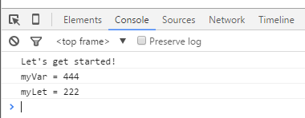

Try changing the value of the constant you created earlier. You will receive error message, at design time, explaining why you can’t change the value.

myConst = 123;

Maybe you think you can just ignore this message and fall back on the Gulp task to transpile this errant TypeScript code.

You’d be wrong…  
  
